Grant Application Form | 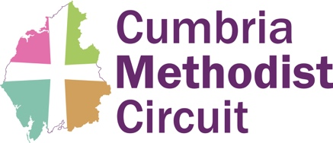

Completed form to be sent to Circuit Grants group by email (grants@cumbriamethodists.org.uk)
To Cumbria Methodist Circuit - Grant Request Application
Application for a grant from: xx Methodist Church

Date: yy 2025

Purpose of grant (description of work):

Proposed work timescale:

Estimated cost of work:

Amount of grant requested:

When would money be needed (approximate date): 2025

Bank details of Church: xx Methodist Church Sort code: xx-xx-xx Account number: xxxxxxxx

Contact details: Name Telephone/Email

Circuit use only

Date considered at Grants:

Decision:

